Project 2 phase 2 Test Result:

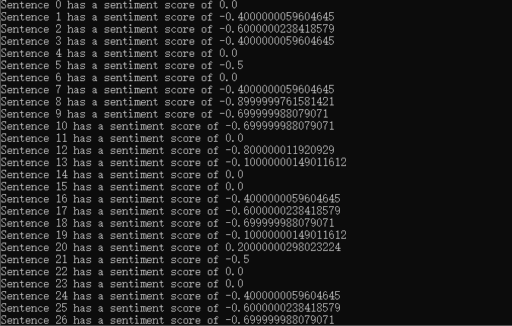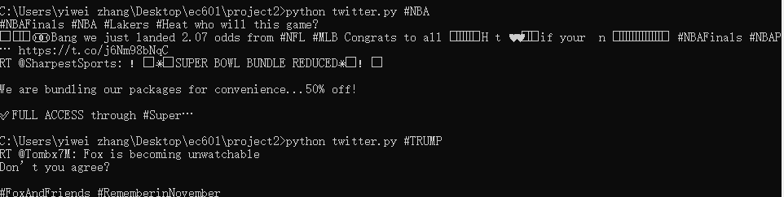you can see that, in the command prompt, I provide a hashtag to python file. That’s where you can search whatever you interested in. And then I let the file print the tweets one by one under that hashtag and In the end is the analyze sentiment result of each tweet and the overall score of that hashtag.

And we can get a sentiment analyze about some specific event or character.